USING A SIMPLE SIR (Susceptible – Infected – Recovered)-like MODEL (spreadsheet “simple 2”):

***Computations:***

The number diseased on the next day is a function of those with symptoms on previous day (the “susceptible” population in SIR) and those with the disease the previous day. The idea is that there is an “interaction” between these two quantities – the more “susceptible” the higher number will get disease, but this is impacted by the possibility of actual exposure which depends on how many have the disease as well.

The formulas governing the three groups of students are:







Where:

*hn* is the number of healthy students on day *n*

*dn* is the number of diseased on day *n*

*cn* is the number effectively treated (cumulatively) on day *n*

and r, s and t are constants describing the spread rate (r), the percent of healthy who get symptoms on a given day (s) and the percent of those with disease that are effectively treated (t)

In the “simple 2” model, once treated the student is no longer either contagious or susceptible, so the number successfully treated are moved into a new category (“cumulative treated”) and they remain there. This is consistent with the SIR model, and fits for a disease like measles etc where once a person has the disease they are no longer susceptible. The total population in the school is thus:

500 = *hn + dn + cn*

The slight modification I made to the typical SIR model is to breake the spread rate constant into a product: in other words, r*s is the usual SIR constant. I did this to allow us to see the number with symptoms at each iteration as that will be a value the game player will want to know in order to make testing/treating decisions…in essence, unlike the usual SIR model where all healthy are susceptible, we first identify a subset of that group (those with symptoms) who are susceptible first.

The other column in the spreadsheet not really in the SIR model is those treated daily. Again, this is likely something we would report for the game player.

Finally, the idea here is that this model governs the disease spread in the school. The *t* percentage is actually variable and will change based on student decisions and the effectiveness of testing/treatments. We don’t actually need to model this explicitly here as we are just interested in seeing model behavior at the extremes (no treatment at all and 100% effective treatment) to ensure the disease spread is reasonable and also at a variety of intermediate treatment values in order to get an idea about behavior for, on average, various levels of test/treatment effectiveness. A more complicated model could be built (and I may do this eventually) in which the t value on each day will change based on inputs from a second sub-model describing the test/treat effectiveness and decisions.

***EXAMPLE:***

School size = 500

Healthy students that have symptoms (may not have disease) = 20% (s = 0.2)

Initially diseased = 5

Spread rate: r = 0.01

***What occurs will depend on how successfully the player identifies and treats subjects. These rates will vary from day to day – for simplicity, the excel worksheet gives examples of what would happen for a constant success rate to give ideas about how the game would progress (roughly).***

***Below are some examples for various treatment rates (t) to illustrate, using the parameters above. Note I did not round to the nearest person in the Excel simulations…this would have a modest impact, but the overall disease spread would look similar.***

**PLAYER 100% SUCCESS RATE (t = 1)**

Here we see that the # Healthy (i.e. never had the disease) drops but then levels off…the disease has died out. In this particular case, about 68 end up getting the disease. This would be the BEST a player could do. With rates as set this occurs somewhere between day 15 and 20 roughly…if truly discretized this will change slightly. We can change the rates (r, s) to change how quickly equilibrium is reached. Alternatively, we can change the initial percentage with the disease – for example, if we start with 20 of the 500 diseased and “perfect” player would be able to end the spread in under 15 days. Of course, a lot more would eventually be infected. The reason the time is shorter is that more susceptibles are removed (and treated) from the healthy population…meaning as the days progress the number diseased each day gets lower more quickly.

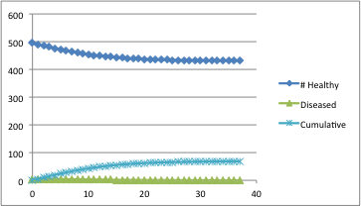

**PLAYER 0% SUCCESS RATE (t = 0)**

As we would expect, the entire school is eventually diseased…takes around 10 days with the rates as set.

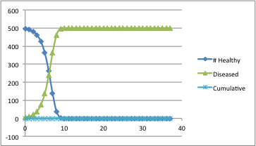

**PLAYER 50% SUCCESS RATE**

The progression starts to become more interesting when success is mixed. Here we see the disease eventually dies off, but the number who never get the disease is less than 100 (we treat 416 approximately in this scenario). Again, about 20 days to end the disease in the school.

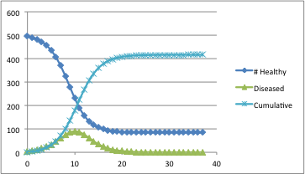

**PLAYER 25% SUCCESS RATE**

This would be pretty poor play, and we probably want to avoid making test/treatment rates so low that a good player cannot do better than this…essentially everyone in the school ends up getting the disease.

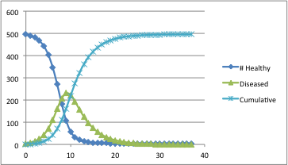

**PLAYER 75% SUCCESS RATE**

This is (maybe) a more realistic rate? In any case, we see similar picture as 50% but just need to treat fewer (meaning fewer end up diseased). In this setting, about half get the disease and thus half end up needing treatment.

